|  |  |
| --- | --- |
| Defect ID | DF001 |
| Tittle | can't display 200 data in post method |
| Test Cases ID | TCA-Post data |
| Reported Date | 5/11/2022 |
| Priority | High |
| Status | On Progress |
| Descriptions | When users send delete requests to the building API containing images, data aren’t deleted |
| Expected Result | Response Code 200, Success Delete |
| Actual Result | Response Code 401, unauthorized |

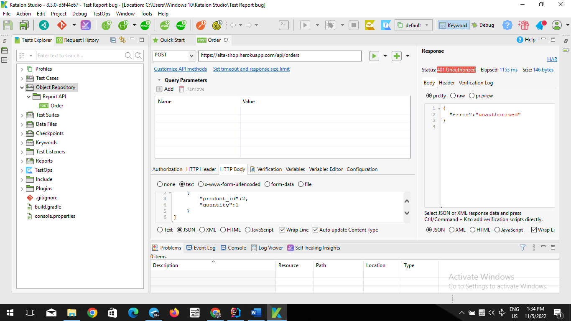

|  |  |
| --- | --- |
| Defect ID | DF002 |
| Tittle | Response body 200 and all data showed |
| Test Cases ID | TCA-Get all orders |
| Reported Date | 05/11/2022 |
| Priority | High |
| Status | On Progress |
| Descriptions | When users send GET blank data and send requests to the building API, response body are data order, but expected result are data ID |
| Expected Result | 200 success |
| Actual Result | 401 error unauthorized |

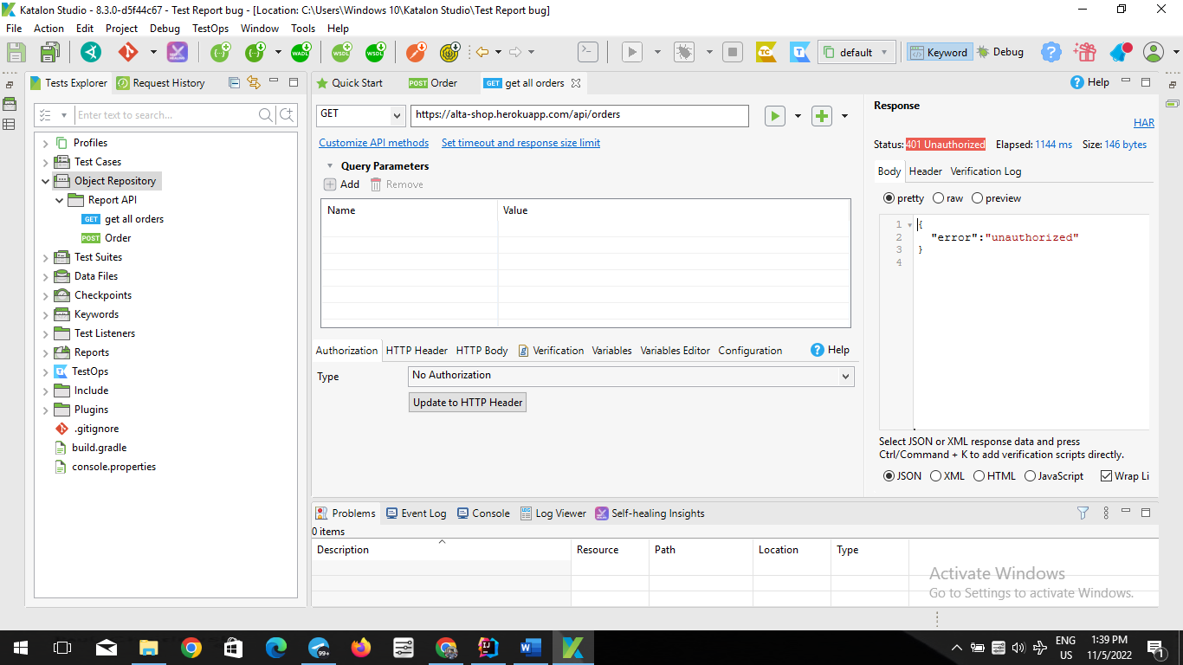

|  |  |
| --- | --- |
| Defect ID | DF003 |
| Tittle | response body displays all data on ID |
| Test Cases ID | TCA-Get Order by ID |
| Reported Date | 5/11/2022 |
| Priority | High |
| Status | On Progress |
| Descriptions | When users send GET blank complex ID the display in the response is "401 UNAUTHORIZED" and does not display data on ID |
| Expected Result | Response Body: Complex ID |
| Actual Result | Response Body: 401 error |

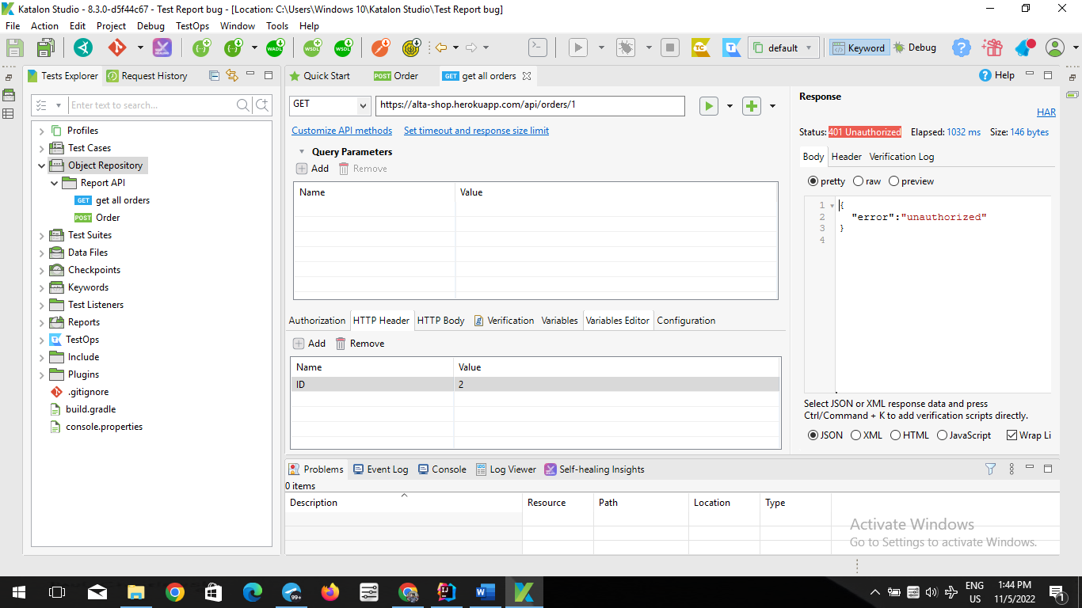

|  |  |
| --- | --- |
| Defect ID | DF004 |
| Tittle | Web UI user wants to click the star button on ratings |
| Test Cases ID | TCW-Rtings |
| Reported Date | 05/11/2022 |
| Priority | High |
| Status | New |
| Descriptions | when the user wants to add stars to the ratings, the result is still the same |
| Expected Result | add stars to ratings |
| Actual Result | Can’t add to stars |

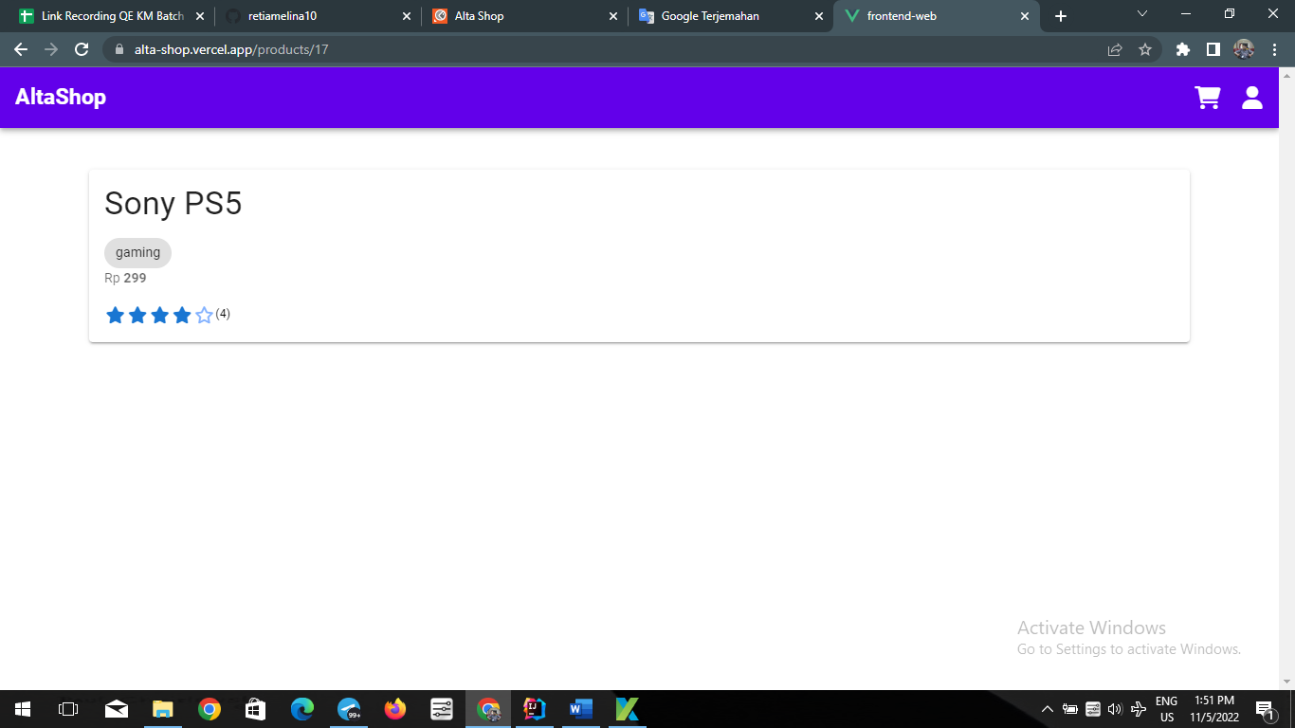

|  |  |
| --- | --- |
| Defect ID | DF005 |
| Tittle | Web UI cancel order on transaction |
| Test Cases ID | TCW- cancel order on transaction |
| Reported Date | 04/07/2022 |
| Priority | High |
| Status | New |
| Descriptions | when the user cancels because of the wrong purchase or accidentally pressed |
| Expected Result | on the transaction page there is a button that can cancel the order |
| Actual Result | there is no order cancellation button on the transaction page |

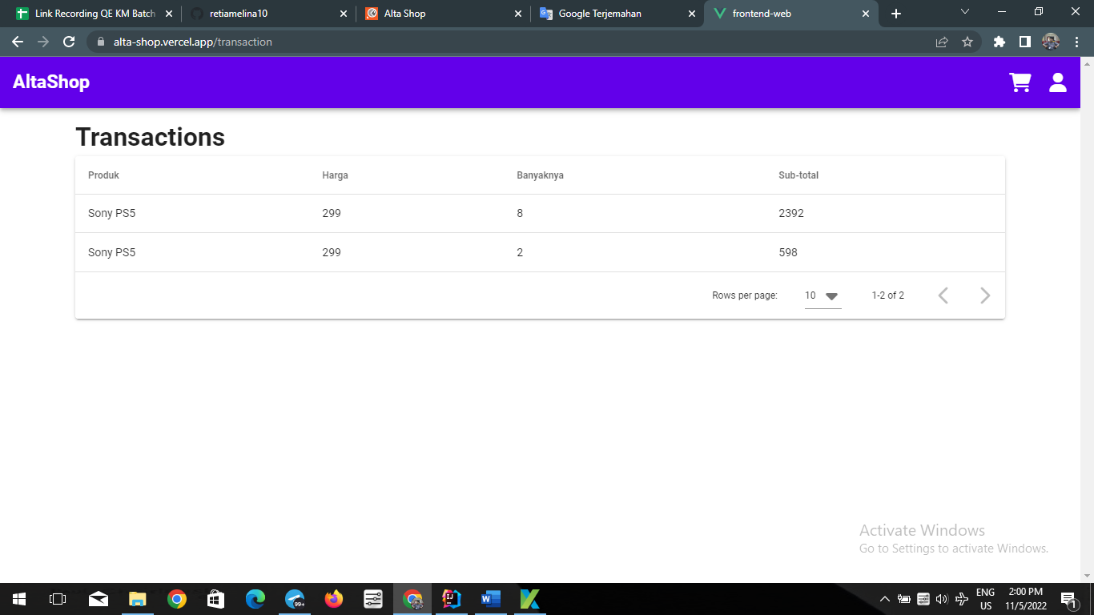

|  |  |
| --- | --- |
| Defect ID | DF006 |
| Tittle | Mobile register when invalid password format |
| Test Cases ID | TCM-Register with invalid password format |
| Reported Date | 07/07/2022 |
| Priority | High |
| Status | New |
| Descriptions | When the user fills the register email using invalid format, and tap register button, the error invalid password is “password kurang dari 8 karakter” |
| Expected Result | Showing error invalid password format |
| Actual Result | No error showed, when the password is the same or more than 8 character |
| Report to | Front End Mobile |

|  |  |
| --- | --- |
| Defect ID | DF007 |
| Tittle | API Unit negative capacity are created |
| Test Cases ID | TCA-Create Unit with negative capacity |
| Reported Date | 11/07/2022 |
| Priority | High |
| Status | New |
| Descriptions | When user fill capacity data using negative number, data are created |
| Expected Result | Error Saved |
| Actual Result | Data Created and negative data saved |
| Report to | Back End |

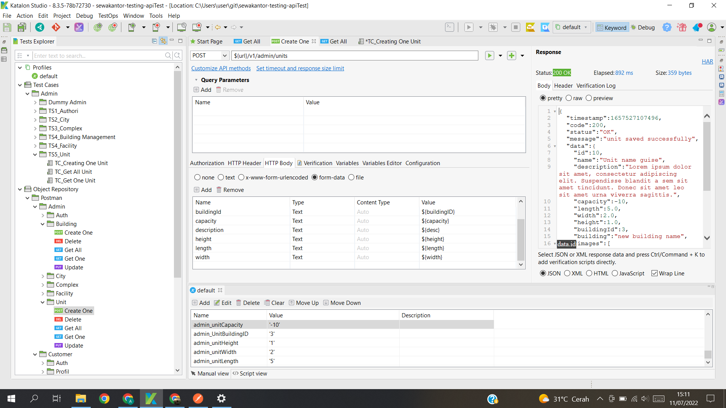

|  |  |
| --- | --- |
| Defect ID | DF008 |
| Tittle | API Unit negative height are created |
| Test Cases ID | TCA-Create Unit with negative height |
| Reported Date | 11/07/2022 |
| Priority | High |
| Status | New |
| Descriptions | When user fill height data using negative number, data are created |
| Expected Result | Error Saved |
| Actual Result | Data Created and negative data saved |
| Report to | Back End |

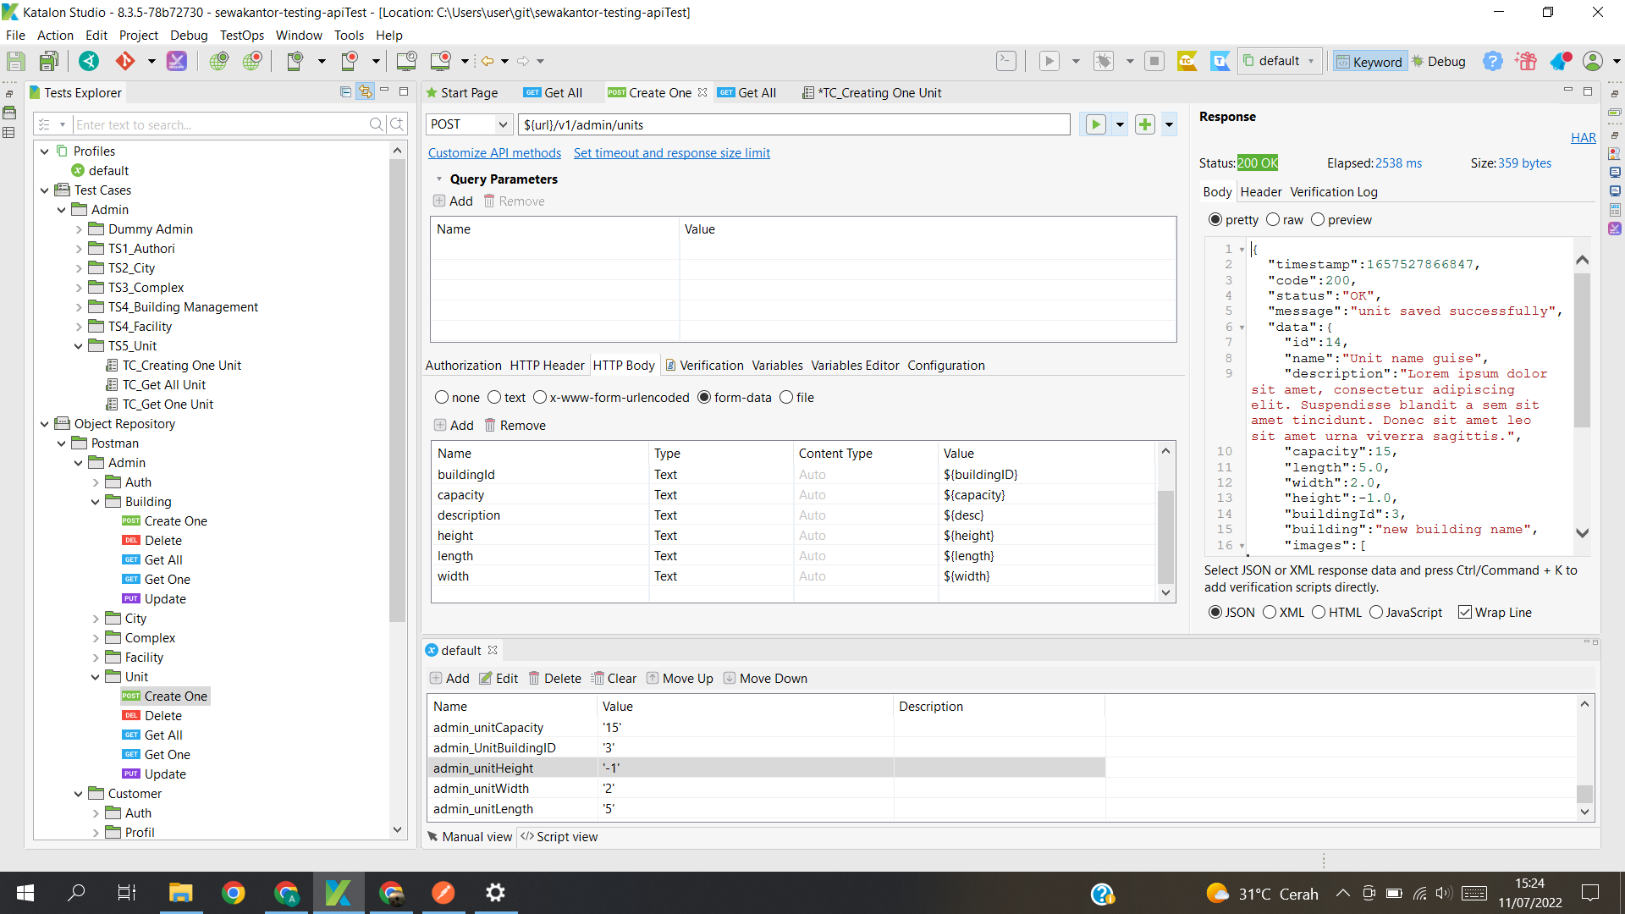

|  |  |
| --- | --- |
| Defect ID | DF009 |
| Tittle | API Unit negative width are created |
| Test Cases ID | TCA-Create Unit with negative width |
| Reported Date | 11/07/2022 |
| Priority | High |
| Status | New |
| Descriptions | When user fill width data using negative number, data are created |
| Expected Result | Error Saved |
| Actual Result | Data Created and negative data saved |
| Report to | Back End |

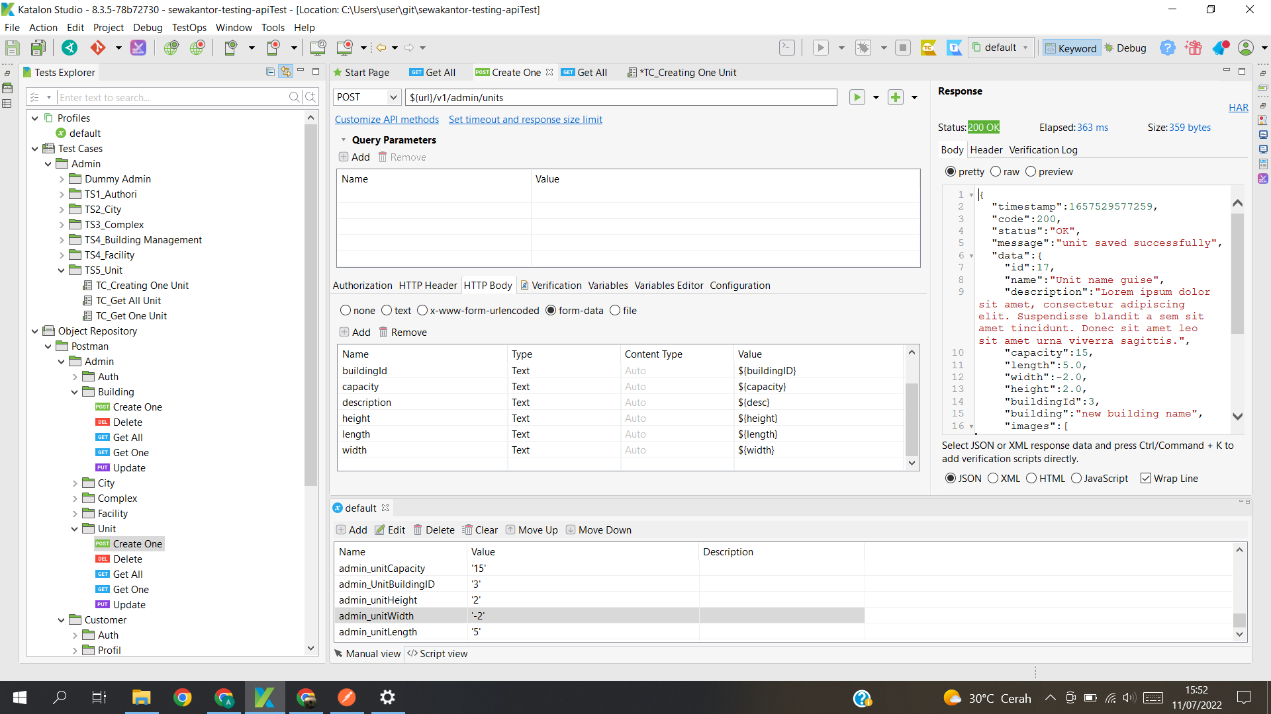

|  |  |
| --- | --- |
| Defect ID | DF010 |
| Tittle | API Unit negative length are created |
| Test Cases ID | TCA-Create length with negative capacity |
| Reported Date | 11/07/2022 |
| Priority | High |
| Status | New |
| Descriptions | When user fill length data using negative number, data are created |
| Expected Result | Error Saved |
| Actual Result | Data Created and negative data saved |
| Report to | Back End |

